Experiment 9: Image Scaling
Aim: To implement image scaling techniques to resize an image to both larger and smaller sizes.
Procedure:
- Read the input image.
- Obtain the original image dimensions.
- Resize the image to a larger size.
- Resize the image to a smaller size.
- Display the original and resized images.
Program:
import cv2
img = cv2.imread(r"D:\Amrita\Pictures\Screenshots\Screenshot 2026-09-30 143819.png")
if img is None:
print("Image not found")
else:
big = cv2.resize(img, None, fx=2, fy=2)
small = cv2.resize(img, None, fx=0.5, fy=0.5)
cv2.imshow("Original Image", img)
cv2.imshow("Bigger Image", big)
cv2.imshow("Smaller Image", small)
cv2.waitKey(0)
cv2.destroyAllWindows()

Input:
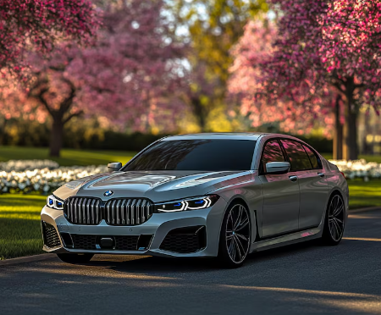
Output:
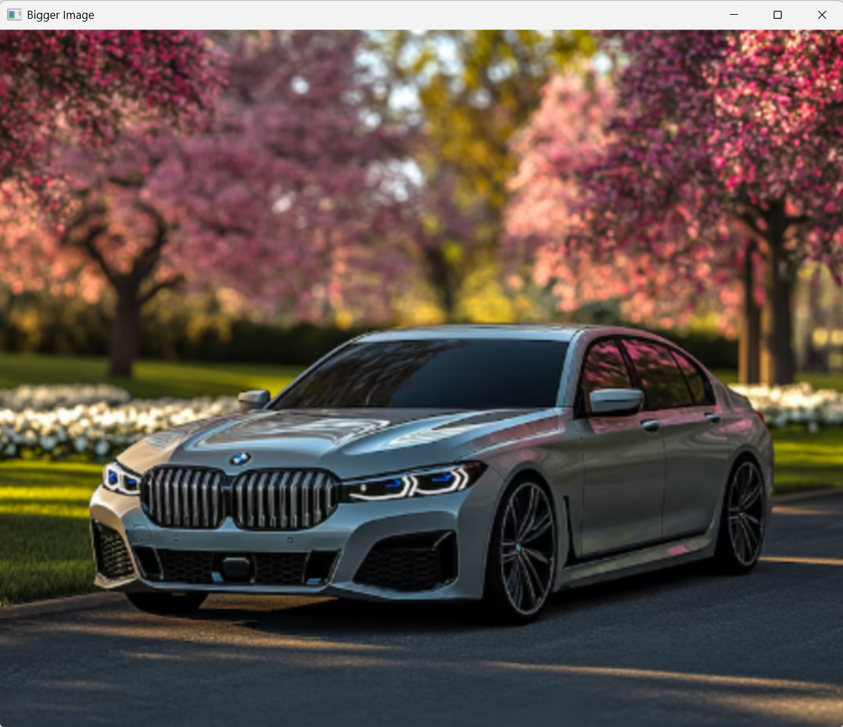
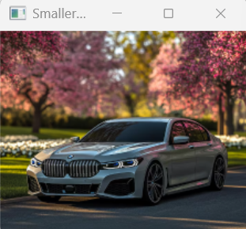

Result:
The input image was successfully resized to larger and smaller dimensions using OpenCV.

